**VIEW**

<div class="row">

**<div class="col-lg-12">**

<h4 ng-repeat='video in selectedVideoList'>

<!-- <h4> -->

<div class="row">

**<div class="col-lg-3">**

**<img** ng-src="img/{{video.SINGERNAME}}.png" >

</div>

**<a href**="" ng-click='getVideo4singer(video)' >

{{video.SINGERNAME}}

</a>

</div>

</h4>

</div>

**<video** controls="controls" name="Video Name" ng-src="{{getVideoUrl()}}"></video>

</div>

**SCREEN**

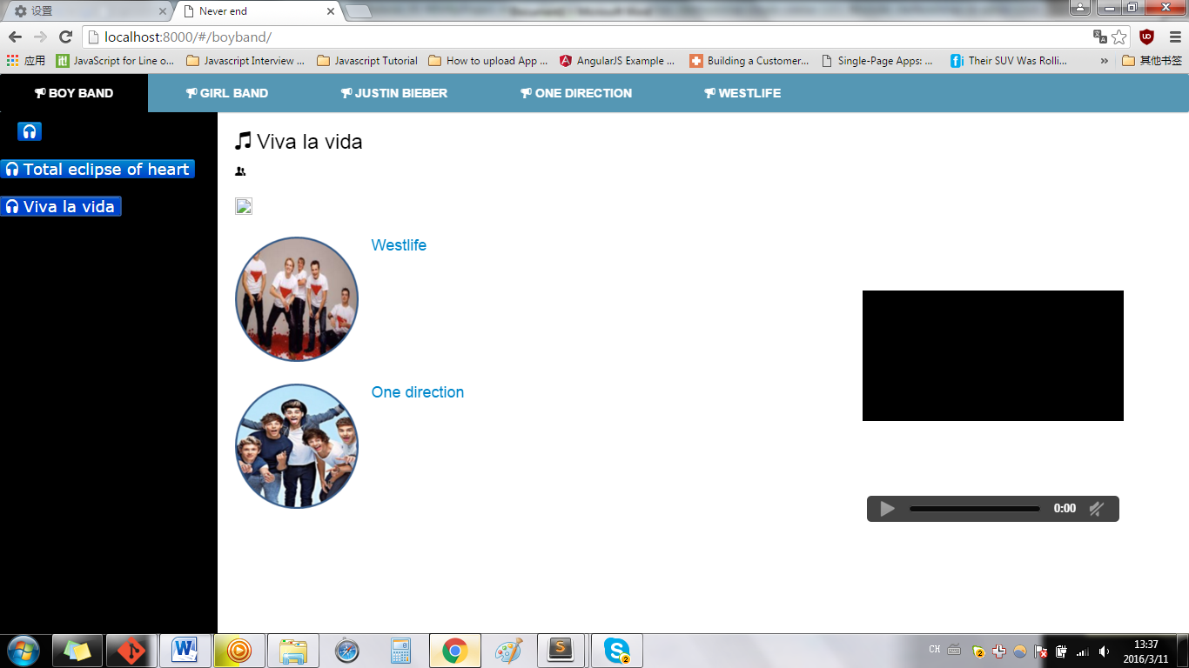

**IF**

<div class="row">

**<div class="col-lg-6">\*\*\*\*\*\*\*\*\*\***

<h4 ng-repeat='video in selectedVideoList'>

<!-- <h4> -->

<div class="row">

**<div class="col-lg-3">**

**<img** ng-src="img/{{video.SINGERNAME}}.png" >

</div>

**<a href**="" ng-click='getVideo4singer(video)' >

{{video.SINGERNAME}}

………..

**SCREEN**

